Learning: is about searching out meaning and imposing structure.

Thinking Skills: supports active cognitive processing which makes for better learning. It equips students to go beyond the information given, to deal systematically yet flexibly with problems and situations. Students should adopt creative and critical attitudes and reflect on what we do.
Thinking styles
Each of us has different thinking styles we operate with. In order to explain different concepts we need to understand where we are starting from. Sternberg (1997) emphasizes that there is not a person with only one style, but a profile of styles. In other words, one person could adopt a variety and combination of them. We as educators have our own styles that we operate with.

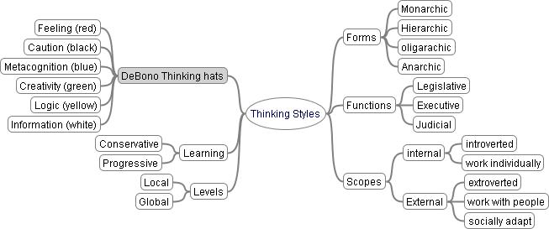
It is important to give learners the time and opportunity to talk about thinking processes, to make their own thought processes more explicit, to reflect on their strategies and thus gain more self-control. Acquiring and using meta-cognitive skills has emerged as a power idea for promoting a thinking skills curriculum … Carol McGuinness (1999)

